# Project Report

|  |  |
| --- | --- |
| Project Title | Plan, Schedule, Test Community Portal |
| Qualification Name (NICF) | NICF-Advanced Certificate in Info comm Technology (Software and Applications) |
| Product Name | NICF-Capstone Project using Java |
| Module Name (NICF) | NICF-Capstone Project using Java |

|  |  |  |  |
| --- | --- | --- | --- |
| Student name | | Assessor name | |
| Escarro, Sebastian Seth R. | |  | |
| Date issued | Completion date | | Submitted on |
|  |  | |  |
|  | |  | |
| Project title | Plan, Schedule, Test Community Portal | | |

|  |
| --- |
| Learner declaration |
| I certify that the work submitted for this assignment is my own and research sources are fully acknowledged.  Student signature:  Date: |

Content

1. Project background
2. Project Objectives
3. Project Requirement Specifications
4. Task 1
5. Task 2
6. Task 3
7. Task 4
8. Task 5
9. Task 6

1. Project Background

ABC Jobs Pte Ltd is asking for a community portal similar to LinkedIn.com for Software Developers. Users can register an account and they can log in to the site using the account they made. The users can request to change their password if ever they forgot it. After making their account, the users can edit their profile page and add their city, country, and company. Users can apply for jobs present at the dashboard and they can search for other users using various parameters and they can view the Public Profile of the users they are searching for by searching for their name or country. They can also post threads, comment on other people’s threads, and reply to comments posted on those threads. An admin account is present which can view all available user and edit or delete their accounts. They can also post new jobs for users to apply to. In order for the project to succeed, it must undergo rigorous testing to ensure the website can deliver a seamless user experience with robust functionality. Potential issues must be resolved in order to assure the project meet the highest standards of performance.

1. Project Objective

The objective of this project is to test the functionality of the ABC Job portal, making sure for a seamless user experience with robust functionality.

2.1 Scope of Testing

In Scope

1. Post Job
2. Apply for Job
3. Post Threads
4. Comment and Reply to Comments on Threads

Out of Scope

1. Registration
2. Login
3. Reset Password
4. Search
5. Update Profile
6. Admin Panel

2.2 Preparation of test scripts

1. Post Job

Scenario: Apply Job

Scenario: Post Thread

Scenario: Comment and Reply on Threads

2.3 Test Execution

1. Project Requirements Specifications

Define the community portal functional features at high level.

Software Programmers

List all the use cases such as login, register, logout, update profile etc

Admin

List all the use cases such as login, log out, bulk email, etc

Test Methods

Chosen tests and benefits

1. Task 1

Task Statement: Write a brief requirement specification for the Community Portal.

4.1 Functional requirements:

a. List of all modules to be developed：

Public Module:

- Landing

- Search Page

- Profile Result Page

- Registration Page

- Login Page

Private Module

- Dashboard

- Thread Comments Page

- Profile Page

- Edit Profile Page

- Admin User Page

- Admin Job Page

b. All pages in each module with a brief description and their purpose.

|  |  |
| --- | --- |
| Web page | Description |
| Landing Page | The first page to appear when opening the website |
| Registration Page | To register as a member of the community portal, it is required to fill in personal information. |
| Thank You Page | The user will get a link in their email. Clicking this will send them to the verification page |
| Verified Page | The verification page will link to the profile page |
| Login Page | Inputting email and password will allow members to login to the community portal |
| Profile Page | This is where the user’s profile information is stored |
| Edit Profile Page | This is where the user can edit the content of their profile |
| Search Page | To search for other users and view their profile |
| Result Page | This is where the user can see the profile of other users |
| Forget Password Page | This page will allow users to change their password when they input their email |
| Reset Password Page | This is where the user can change their password |
| Dashboard Page | Where users can post and view threads. Also, where users can apply for a job |
| Thread Page | Where users can post/view comments for threads and post/view replies for comments |
| Admin User Page | This where the admin can edit or delete |
| Admin User Profile Update Page | This is where the admin can change a user’s info |
| Admin Job Page | This is where the admin can add jobs. Admin can open or close jobs and decide to accept or reject job applications |

c. All pages in each module which are create, edit and view pages

|  |  |
| --- | --- |
| Landing Page | View |
| Registration Page | Create |
| Thank You Page | View |
| Verified Page | View |
| Login Page | Select |
| Profile Page | Select, View |
| Edit Profile Page | Select, Edit |
| Search Page | Select, View |
| Result Page | Select, View |
| Forget Password Page | Select, Edit |
| Reset Password Page | Edit |
| Dashboard Page | Select, View, Create |
| Thread Page | Select, View, Create |
| Admin Page | Select, View, Delete |
| Admin Update Page | Select, Edit |
| Admin Job Page | Select, View |

d. Sitemap of Public & Private Site

Public

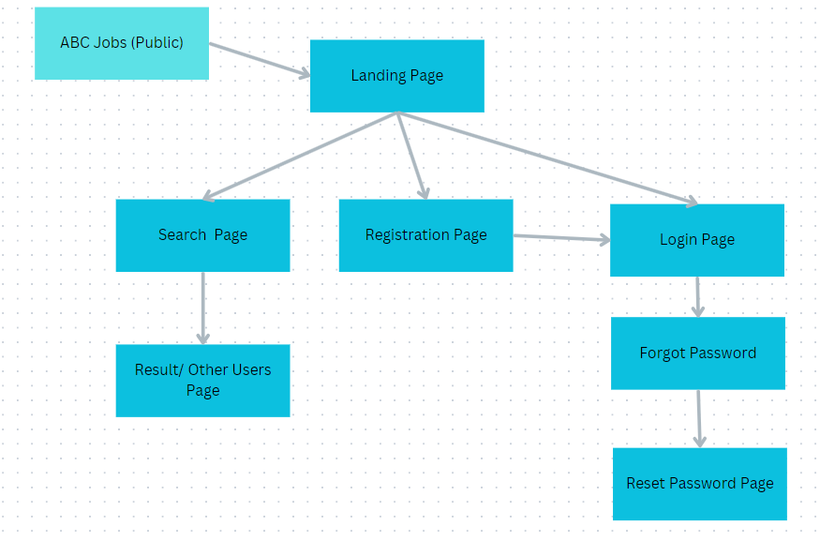

Private

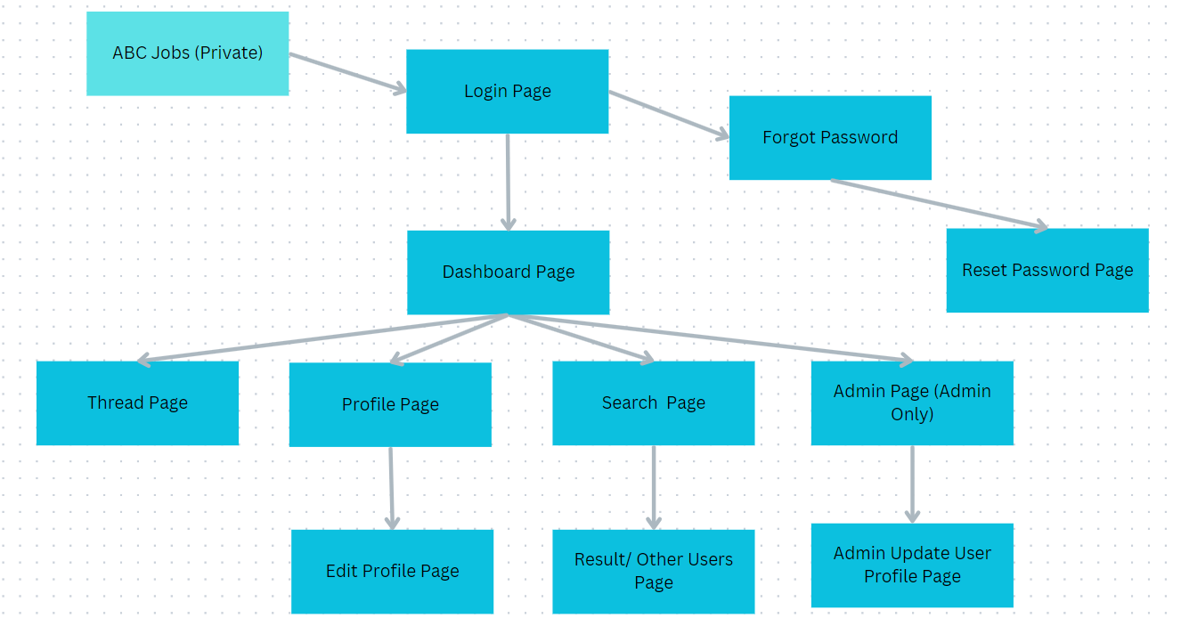

4.2 Non-Functional Requirements

1. Portability Requirements
2. Maintainability Requirements
3. Performance Requirements
4. Security Requirements

4.3 Technical Environment Requirements

System requirements

* 1. Hardware
     1. Processor: Intel Core i5
     2. RAM: 8 GB
     3. SSD: 400 GB
  2. Software
     1. Windows 11
     2. Eclipse IDE
     3. MySQL Workbench
     4. JDK 18

System Integration Requirements

No external software are utilized for system integration/development.

4.4 Testing Requirements

|  |  |
| --- | --- |
| Testing | Tools |
| Unit Testing | Localhost:8080, browser, Eclipse |
| Integration Testing | Localhost:8080, browser |
| UAT Testing | Localhost:8080, browser |
| Performance Testing | Localhost:8080, browser, Chrome DevTools |
| Usability Testing | Localhost:8080, browser, Chrome DevTools |
| Cross-Browser Testing | Participant |

1. Task 2

Task Statement: Briefly explain different types of testing, how they will help to create a better system

Solution: Presentation

Functional testing:-

<any three testing methods>

Non-Functional testing:-

<any three testing methods>

1. Task 3

Task Statement: Propose relevant tests suitable for the Project Scenario

Solution: Presentation

Functional testing:-

1. Unit testing

|  |  |  |  |
| --- | --- | --- | --- |
| Test Id | Test Scenario | Test Objective | Expected Result |
| TS001 | UT001 | Identify whether admin can add jobs | Job should be available for users to see on dashboard |
| TS002 | UT002 | Identify whether user can apply for jobs and if admin can see them | Job application should be present on admin job page. After admin accepts or rejects the application, user should see status on dashboard |
| TS003 | UT003 | Identify whether user can post threads for other users to see | Post should be seen first on dashboard page with the posting user’s email and initials |
| TS004 | UT004 | Identify user can post comments for threads and reply to comments | Comment should be seen on the thread with commenting user’s email and initials |

1. Integration Testing

|  |  |  |  |
| --- | --- | --- | --- |
| Test Id | Test Scenario | Test Objective | Expected Result |
| TS005 | IT001 | Identify whether admin can add jobs | Job should be available for users to see on dashboard |
| TS006 | IT002 | Identify whether user can apply for jobs and if admin can see them | Job application should be present on admin job page. After admin accepts or rejects the application, user should see status on dashboard |
| TS007 | IT003 | Identify whether user can post threads for other users to see | Post should be seen first on dashboard page with the posting user’s email and initials |
| TS008 | IT004 | Identify user can post comments for threads and reply to comments | Comment should be seen on the thread with commenting user’s email and initials |

1. User Acceptance testing

|  |  |  |  |
| --- | --- | --- | --- |
| Test Id | Test Scenario | Test Objective | Expected Result |
| TS001 | UAT001 | Identify whether admin added job is reflected on dashboard | Job should be available for users to see on dashboard |
| TS002 | UAT002 | Identify if admin can accept job applications | Job application should be present on admin job page. After admin accepts or rejects the application, user should see status on dashboard |
| TS003 | UAT003 | Identify whether user can post threads for other users to see | Post should be seen first on dashboard page with the posting user’s email and initials |
| TS004 | UAT004 | Identify if users can comment on threads and reply to comments |  |

Non-Functional testing:-

1. Cross browser testing
2. Usability testing
3. Task 4

Task Statement:-

Write briefly on optimal scheduling times for different tests 2.

Prepare a schedule for execution of tests

Include it as part of Project Presentation.

|  |  |  |  |
| --- | --- | --- | --- |
| **Web page** | **Weighting** | **Functional Points (FP)** | **Total** |
| Dashboard | 3 | 5 | 15 |
| Thread | 3 | 5 | 15 |
| Admin Job | 3 | 3 | 9 |
|  |  | Total functional points | 39 |
|  |  | Estimated person hour per FP | 2.0 |
|  |  | Total hours needed | 78 hours |
|  |  | Total days needed | 9 days |

**Test Schedule**

|  |  |  |  |
| --- | --- | --- | --- |
| Test Schedule ID: | TS0001 |  |  |
| Product ID / Name: | ABC Community portal website |  |  |
| Product Version or Build: | 1.1 |  |  |
| Present Owner: | ABC Job Pvt LTD |  |  |
| Created On: | 7/27/23 | 8/17/23 |  |
| Review On: | 8/14/23 | 8/17/23 |  |
| Review By: | Jeanne Dominique Paloma | QA Manager |  |
| Review Comments: | Job Application and Thread Posting works like a charm. User’s are only allowed to apply for the job once, any attempt to apply again will lead to an alert. User’s can comment on threads and leave replies for those comments |  |  |
| Current Version: | 1.1 |  |  |
| Change Details: | * Added Job page for admin with Add Job, Close/Open Job Listings, Accept/Reject Job Applications * Added dashboard page with thread posting, thread commenting and replying, Job Applying * UI Changes |  |  |
| Current Status: | Approved | 8/18/23 |  |
| Signing Off Authority: | Archana Sakpal  Siti | QA manager  PM | 8/18/23 |

**Task 5: Phase Test Plan**

|  |  |  |  |  |
| --- | --- | --- | --- | --- |
| Task | Start Date | End Date | Duration | Resource |
| Project Initiation | 7/27/2023 | 7/27/2023 | 0 | Escarro |
| Planning of Features to be developed | 7/27/2023 | 7/28/2023 | 1 | Escarro |
| Requirement and Gathering Analysis | 7/27/2023 | 7/28/2023 | 1 | Escarro |
| Design Dashboard page | 7/28/2023 | 7/29/2023 | 1 | Escarro |
| Implement Dashboard Page | 7/28/2023 | 7/29/2023 | 1 | Escarro |
| Develop Job Post and Apply | 7/31/2023 | 8/9/2023 | 9 | Escarro |
| Develop Threads | 7/31/2023 | 8/10/2023 | 10 | Escarro |
| Testing and Bug Fixing | 8/10/2023 | 8/17/2023 | 7 | Escarro |
| Project Review and Wrap Up | 8/17/2023 | 8/18/2023 | 1 | Escarro |
| Deploy Project | 8/18/2023 | 8/18/2023 | 0 | Escarro |

Task Statement: Develop a Phase Test Plan for testing the application.

Solution

Analyze the product to define the features to be tested and not

Design Strategy – Plan the test, Define suspension, and resumption and exit criteria

Execute – Test Cases, Test scripts

Reporting – Test Metrics – IU1 Slide 35 & 36

Goal

The goal of this test is to identify and measure the problems / issue in the web application.

Objectives

Validate and verify system functionality works according to requirements.

**Features not to be tested**

1. Registration
2. Login
3. Reset Password
4. Search
5. Update Profile
6. Admin Panel

**Features Be Tested**

1. Post Job
2. Apply for Job
3. Post Threads
4. Comment and Reply to Comments on Threads

**Approach**

1. Unit Testing
2. Integration Testing
3. UAT
4. Performance Testing
5. Usability Testing
6. Cross-Browser Testing

**Suspension Criteria**

Component testing will be suspended under the following conditions:

1. Critical errors found preventing test completion
2. Change

Resumption Criteria

Component testing will resume when the following criteria are met:

1. All issues in suspension criteria have been resolved or mitigated
2. New software build has been redeployed
3. New build with fixed Critical

**Exit Criteria (Test Completeness)**

Component testing can be considered complete when the following conditions have been met:

1. All High and Medium priority requirements have been tested without Critical or Medium severity defects.
2. All defects have been fixed and resolved.
3. All modules tested meet the requirement specification/standard.

**Test Metrics**

|  |  |  |
| --- | --- | --- |
| **Test Metric** |  | **Testing Phase** |
| Number of Test Cases |  | Test Development Phase |
| Number of Test Cases Passed |  | Test Execution Phase |
| Number of Test Cases Executed |  | Test Execution Phase |
| Number of Test Cases Failed |  | Test Execution Phase |
| Number of Test Cases under Investigation |  | Test Development Phase |
| Number of Test Cases Blocked |  | Test Development Phase / Execution Phase |
| Number of Test Cases Re-executed |  | Regression Phase |
| Number of First Run Failures |  | Test Execution Phase |
| Total Executions |  | Test Reporting Phase |
| Total Passes and Failures | Pass:  Failure: | Test Reporting Phase |
| Test Case Execution Time |  | Test Reporting Phase |
| Test Execution time |  | Test Reporting Phase |

**Defect Rate**

|  |  |
| --- | --- |
| % of Test cases Passed |  |
| %of Test Coverage |  |
| % of Defects corrected |  |
| % of Test cases Blocked |  |
| % of Rework |  |
| % of Test Effectiveness |  |

**Test Deliverables**

1. Phase Test plan
2. Test schedules
3. Test scripts
4. Test Results
5. Bugs write-up
6. Task 6

Task Statement: Execute the test created, take appropriate screen capture & include it as part of Project Presentation

Solution Presentation